17.112: Denote the quantites for copper, brass and steel by 1, 2 and 3, respectively, and denote the temperature at the junction by 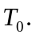
a)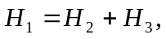 and using Eq.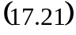 and dividing by the common area,
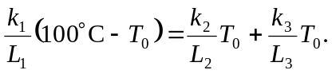
Solving for 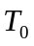 gives
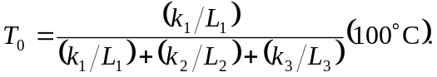
Substitution of numerical values gives 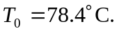
b) Using 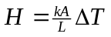 for each rod, with 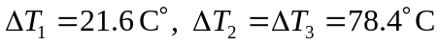 gives If higher precision is kept, 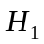 is seen to be the sum of 